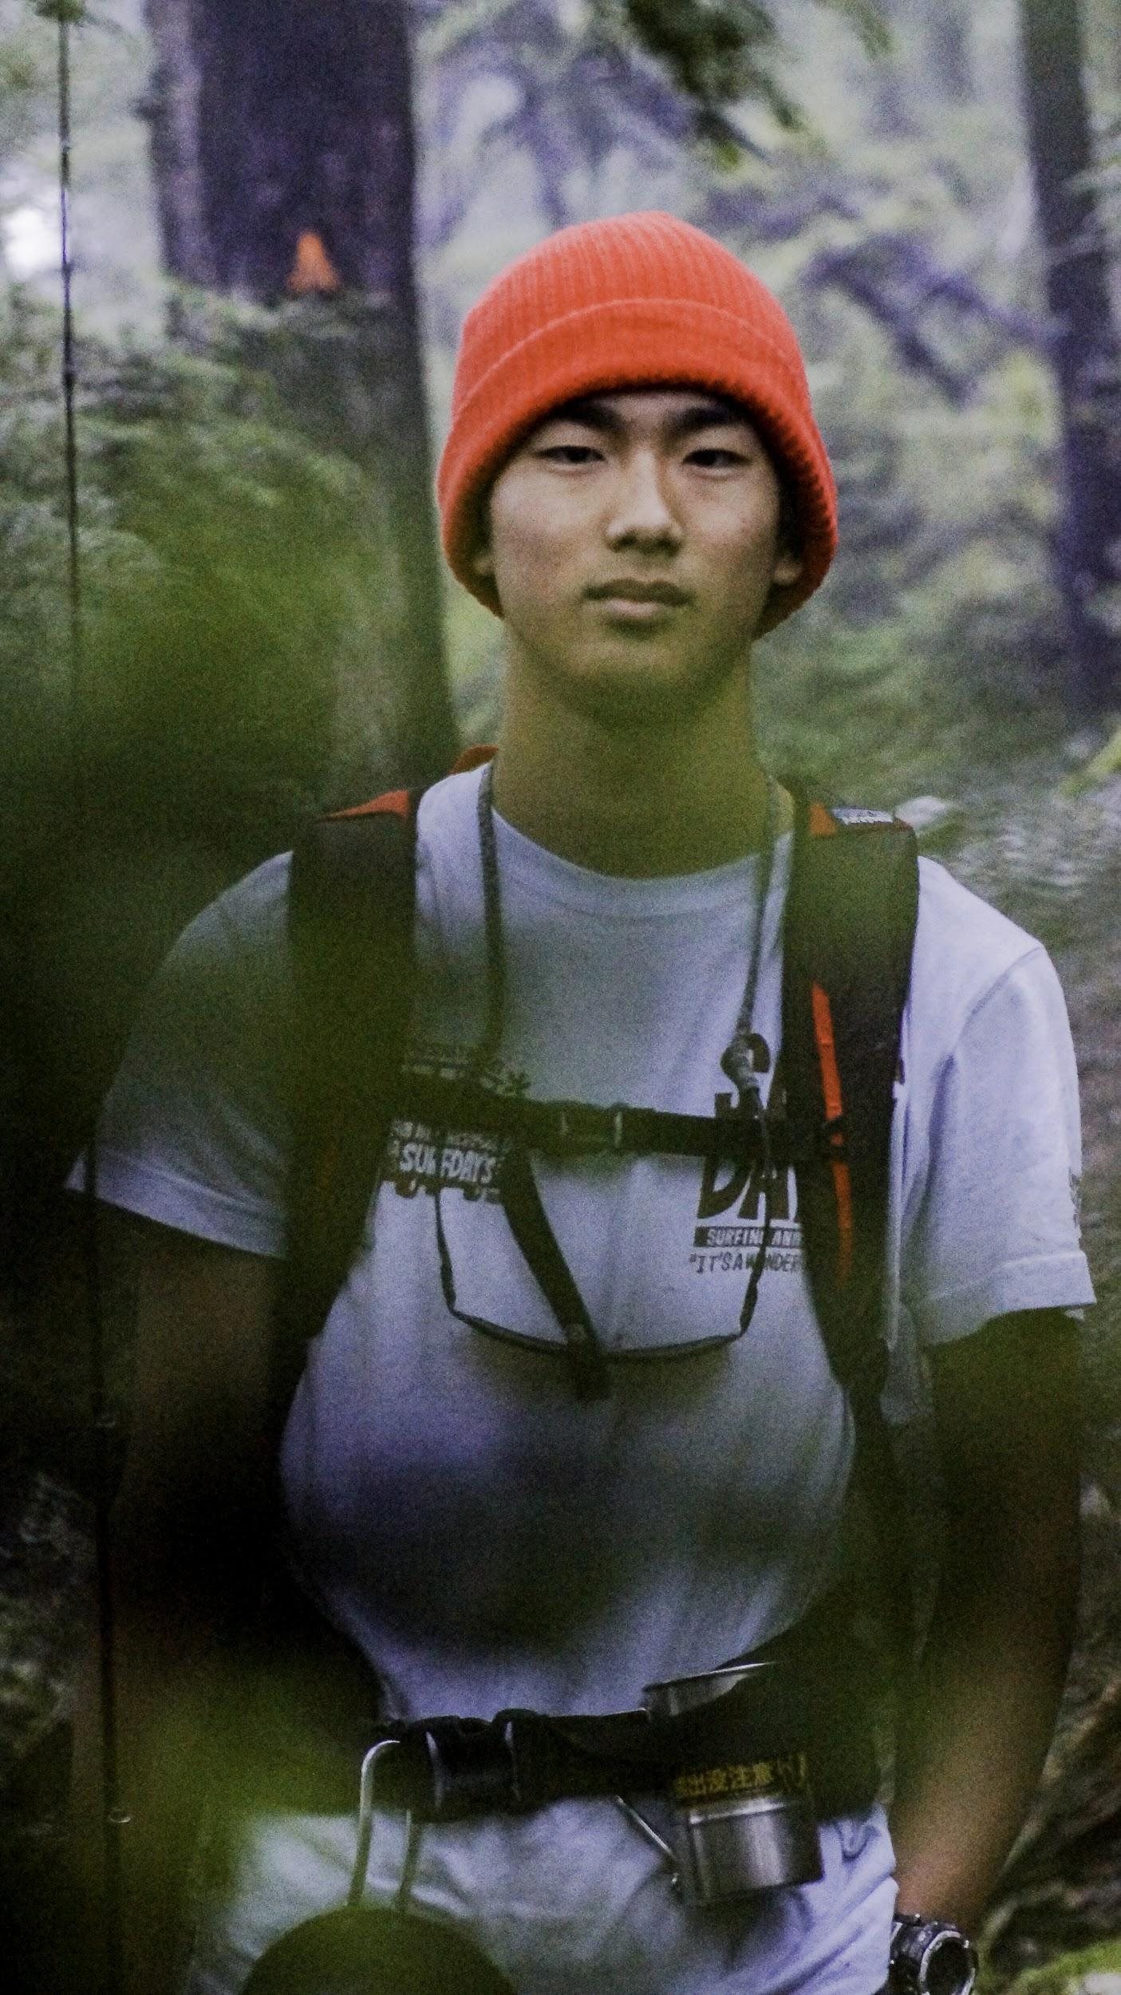

Dropping everything to live and go to school in a completely different country, could be a pretty daunting concept for most. 17 year old, Kaisei Mizuta did just that and he’s loving it.

Imagine throwing yourself into the deep end and getting lost in a country that speaks an entirely different language (two in fact). I’d say you have to be pretty brave to do that.

Kai was tired of everything in Japan being done for him and craved a bit more freedom. So he fled the coop and shipped off to New Zealand for a few years.

I first saw Kai on his first day in New Zealand. I was at the skate park in Rangiora when a Japanese kid rocked up looking steezy as hell. After a few weeks of hanging out with him not only had his skating improved but his English was pretty impressive too. We gave him the true kiwi experience right from the word go, from fish and chips to eeling at the river. From cheeseburgers to filming a feature length skate film

Chatting with him made me realise something I think I take for granted. He said that he had nothing to stress about since he got here and he is so happy to be in such a beautiful country.

How long are you here for?

5 months

Why did you decide to come to NZ?

I like fishing. I knew New Zealand has good trout, many, many trout

My life, more by myself, more free.

How did you afford to come?

For one year I was working in a steak restaurant. Washing dishes. And My family was a big help.

Fav thing so far

Nature.

How is school in NZ different from Japan?

New Zealand school has not enough free time, not too much studying time. In japan after last period, we have to clean the whole school for about 40 minutes. High school is usually 7 periods, sometimes 8.

What do you miss from Japan?

Sometimes meals. I like New Zealand food. Lamb!

What is your Favourite Japanese meal?

It's not Japanese food, but do you know Chauhan? Chauhan is Chinese food. I've never seen it in New Zealand.

Do you like Jpop?

Jpop? No.

What about Kiwi music?

Oh yes… Poi-e

What music do you actually like?

Um, The Specials, Grateful dead. I like Grateful dead

Who’s is your favourite skater?

Just one?

Who are your favourite skaters?

I like Cyrus Bennett, Alex Olsen, Hjalte Halberg, Ben Kadow.

Did you shave your hair to look like Kadow?

Hahaha yep.

Oh, and GT (Grant Taylor)

What did you think when GT and the AntiHero team came to Christchurch?

Very very hyped. Excited. Yeah, unbelievable.

Fishing or skating?

If I go fishing, “oh fishing is better!” If I go skate “oh skating is better!” If I go snowboarding “oh snowboarding!”

Did you snowboard much in Japan?

My father is quite busy. So not too often.

Got a girl?

What!? No.

What about Alex?

F\*\*\* off!

Do you think you’ll end up living in New Zealand?

I want to go back to Japan, but not forever. I Like New Zealand. My future is living somewhere, not in Japan. I think New Zealand. Alaska is too cold, Copenhagen has no hill bombs, yeah New Zealand’s good. I’m not sure about Utah… but Utah looks good.